SAULT COLLEGE OF APPLIED ARTS AND TECHNOLOGY

SAULT STE. MARIE, ONTARIO

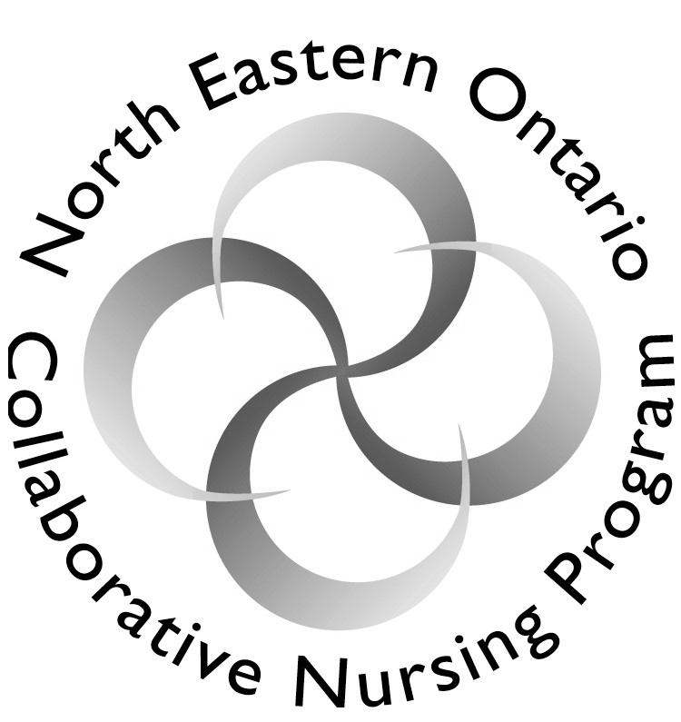

COURSE OUTLINE

COURSE TITLE: | Nursing Practice III
CODE NO. : | NURS2094 |  | SEMESTER: | 4
PROGRAM: | Collaborative Bachelor of Science in Nursing
AUTHOR: | Linda Chow, Marilyn King, Brenda Roseborough, Johanne Carbonneau, Mimi Walsh, Mary Lou Trowell, Gloria Viverais-Dresler, Theresa Mirka
DATE: | January  2004 | PREVIOUS OUTLINE DATED: |  |  | Jan. 2003
APPROVED:
 | __________________________________  DEAN |  |  |  | _______  DATE
TOTAL CREDITS: | 4
PREREQUISITE(S): | NURS 2006, NURS 2084, BIOL 2111
HOURS/WEEK: | 3 (classroom), 3 (Laboratory),  110 (Clinical), 22 (Community)

Copyright ©2004 The Sault College of Applied Arts & Technology
Reproduction of this document by any means, in whole or in part, without prior

written permission of Sault College of Applied Arts & Technology is prohibited.

For additional information, please contact the Dean
School of Health and Human Services
(705) 759-2554, Ext. 603/689

I. | COURSE DESCRIPTION:  This nursing practice experience is a continuation of Nursing practice II, with a focus on increasingly complex health challenges. There will be opportunities for learners to refine their clinical judgment and decision-making and to explore and utilize the expertise of a variety of health team members. Clinical experience will occur in both the community and health care agency with a focus on complex health challenges.

II. | LEARNING OUTCOMES AND ELEMENTS OF THE PERFORMANCE:
ENDS-IN-VIEW:

In this course, learners will have the opportunity to further develop their understanding of
a variety of concepts of relevance to clients (individual, and family) during client experiences with complex health challenges. Student learning opportunities in this nursing practice course will also be focused on the planning, implementation and evaluation of nursing care when clients are experiencing complex health challenges.

Learners will be active participants in the development of their own knowledge through praxis. Opportunities will be provided for learners to develop caring relationships with clients and their families in various settings Opportunities will be provided for learners to assess, plan, intervene and evaluate holistic care for clients (individual and family) in the acute care setting. Learners will have the opportunity to further develop documentation skills and to practice nursing safely in all client situations.

PROCESS:

With the help and guidance of a faculty member, learners will explore selected practice situations, and further develop nursing practice skills in the laboratory setting. Through case studies, discussion, role-playing, and clinical practice, learners will refine clinical judgment skills and explore safe professional nursing practice. The utilization of a framework for intervention will facilitate priority setting and decision-making and will help to highlight specific nursing roles when working with individuals and their families experiencing complex health challenges. Learning activities, journaling, and sharing by classmates of their experiences in hospital and community will provide opportunities to explore community resources available to clients (individual and family) experiencing complex health challenges.

III. | TOPICS:
 | 1. |  | Critical thinking | 7. | Death, & Dying
 | 2. |  | Nursing process | 8. | Depression & Anxiety
 | 3. |  | Healing | 9. | Hope
 | 4. |  | Health related quality of life | 10. | Loss, Bereavement, & Grief
 | 5. |  | Stress and adaptation | 11. | Pain & Suffering
 | 6. |  | Hardiness
V.  **  ** |  | REQUIRED RESOURCES/TEXTS/MATERIALS:  Carpenito, L.J. (2002). Nursing Diagnosis: Application to clinical practice. 10th ed. Philadelphia: Lippincott.  Guzzetta, C. E. (1998). Essential readings in Holistic Nursing. Maryland: Aspen  Smeltzer, S.C., & Bare, B.G. (2004). Brunner & Suddarth’s textbook of medical-surgical nursing (10th ed). Philadelphia: Lippincott.  Karch, A. (2004). Lippincott’s nursing drug guide. Philadelphia: Lippincott.  Lehne, R.A. (2001). Pharmacology for nursing care (4th ed.). St. Louis: Saunders  An alternate medical-surgical textbook is:  Lewis, S.M., Heitkemper, M. & Dirksen, S. (2004). Medical surgical nursing: Assessment and management of clinical problems (6th ed.). St. Louis: Mosby.  McCance, K.I. & Heuther, S. E. (2002). Pathophysiology: The biological basis for diseases in adults and children (4th ed.). St. Louis: Mosby.  You will need access to a mental health nursing textbook (Library).  Previously Purchased:  Wilkinson, J.M. (2001). Nursing process and critical thinking. New Jersey: Prentice Hall.  Fischbach, F. (2002). Nurses’ quick reference to common laboratory and diagnostic tests (3rd ed.). Philadelphia: Lippincott.  Selected readings and articles as outlined in each learning activity for each concept (on reserve) in the library.  You will need to seek out additional library resources such as journals, and internet sources such as Cinahl and Proquest and the Cochrane Library for your weekly case studies

V. | ATTENDANCE POLICY  Class:  The learning activities provided with the NURS 2006 course syllabus and the specific case studies for NURS 2094 will outline the preparatory material for each class. It is very important that students come to class prepared and bring along necessary texts and resources needed to function as a group member.  Punctual and regular attendance at the various academic exercises is required of all students. After a lecture has begun, students may not be admitted to a classroom without the instructor’s permission. If there are extenuating circumstances bearing upon a student’s absence, the instructor should be notified. Absences in excess of 20% may jeopardize receipt of credit for the course.  Laboratory experience:  Laboratory classes will be three hours in length. Your attendance at weekly laboratory sessions is mandatory. Students are expected to come to lab prepared as outlined in the Learning Activities for the Lab.  A Practice Lab is available for students to further develop their clinical skills (for access see the Sault College Bachelor of Science Degree in Nursing Student Manual – Student Services). If a student has problems with the performance of skills in the clinical area any needed remedial work must be discussed with their clinical instructor. Continued problems with the performance of skills may require that the student leave the clinical setting.  Clinical Practice:  In this course, clinical practice for the learners consists of acute care experience in the hospital setting (110 hours) and community experience (22 hours) . Community clinical hours & expectations will be discussed in class. Students are expected to prepare for each clinical day as instructed by their professor and to complete their portfolios and post-conference activities as assigned.  Nursing students enter a new clinical area as novices; they have little understanding of the contextual meaning of the recently learned textbook terms. But students are not the only novices; any nurse entering a clinical setting where he/she has no experience with the patient population may be limited to the novice level of performance if the goals and tools of patient care are unfamiliar. (Benner, 1984, p.21)  Clinical attendance is mandatory. If a student is absent from clinical a  Physician slip may be required. The necessity of Physician’s note should be discussed with the clinical teacher. You must arrange a meeting with your clinical instructor to explore options to meet the required clinical hours.
V. |  | EVALUATION PROCESS/GRADING SYSTEM:  A passing grade of 60% is required for this and all nursing courses. In order to facilitate your problem solving skills by utilizing the nursing process, the Major assignment will be joint. The assignment requires that the learner pull information and learning from both nursing courses (Nurs 2007 and Nurs 2094). The grade for NURS 2094 will be derived from the following four (4) methods of evaluation.  1. Midterm test 15%  The format of the test may include multiple choice questions, short  answer questions, or a brief case study.  2. A major assignment 35%  Joint case study with Nurs 2007- the section of this assignment credited to NURS2094 will be reviewed in class.  3. Community Assignment 10%  Criteria will be discussed in collaboration with the course  professors. This assignment will be site specific depending on  assessed needs and available experiences.  4. Final examination 40%  The final exam will include multiple choice questions, short answer  items, and case studies. It will include material from class and lab  sessions.  5. Clinical Experiences “Satisfactory” or “Unsatisfactory.  * Note: Clinical experiences include hospital and community. The learner must demonstrate “SATISFACTORY” performance on the Clinical Evaluation for hospital placement, including a rating of three on all of the indicators of clinical performance and have completed the assigned community hours in order to obtain a passing grade in NURS 2094. They must also successfully complete the professional portfolio. The clinical portfolio includes weekly preparatory work as assigned by the clinical teacher, and reflections using John’s Model as assigned.  Failure to achieve a passing grade in either the clinical and/or the class component of the course requires the student to repeat all components of NURS 2094.  Attendance at scheduled tests, quizzes, laboratory sessions, clinical experience, presentations, examinations, etc. is mandatory.  Missed tests, quizzes, assignments, laboratory reports, presentations, examinations could be graded “0” unless alternate arrangements are made with the professor prior to the scheduled times.  The North Eastern Ontario Collaborative Nursing Program Student Manual is to be consulted for guidance and is considered part of this course outline.
 |  | The following semester grades will be assigned to students in postsecondary courses:

 | Grade | Definition | Grade Point Equivalent
 | A+ | 90 - 100% | 4.00
 | A | 80 - 89% | 3.75
 | B | 70 - 79% | 3.00
 | C | 60 - 69% | 2.00
 | D | 50 – 59% | 1.00
 | F (Fail) | 49% and below | 0.00
 | CR (Credit) | Credit for diploma requirements has been awarded.
 | S | Satisfactory achievement in field /clinical placement or non-graded subject area.
 | U | Unsatisfactory achievement in field/clinical placement or non-graded subject area.
 | X | A temporary grade limited to situations with extenuating circumstances giving a student additional time to complete the requirements for a course.
 | NR | Grade not reported to Registrar's office.
 | W | Student has withdrawn from the course without academic penalty.

VI. | SPECIAL NOTES:
Special Needs:
If you are a student with special needs (e.g. physical limitations, visual impairments, hearing impairments, or learning disabilities), you are encouraged to discuss required accommodations with your instructor and/or the Special Needs office. Visit Room E1204 or call Extension 493 so that support services can be arranged for you.

Retention of course outlines:
It is the responsibility of the student to retain all course outlines for possible future use in acquiring advanced standing at other postsecondary institutions.

Plagiarism:
Students should refer to the definition of “academic dishonesty” in Student Rights and Responsibilities. Students who engage in “academic dishonesty” will receive an automatic failure for that submission and/or such other penalty, up to and including expulsion from the course/program, as may be decided by the professor/dean. In order to protect students from inadvertent plagiarism, to protect the copyright of the material referenced, and to credit the author of the material, it is the policy of the department to employ a documentation format for referencing source material.

Course outline amendments:
The Professor reserves the right to change the information contained in this course outline depending on the needs of the learner and the availability of resources.

 | Substitute course information is available in the Registrar's office.

VII. | PRIOR LEARNING ASSESSMENT:
 | Students who wish to apply for advanced credit in the course should consult the professor. Credit for prior learning will be given upon successful completion of a challenge exam or portfolio.
VIII. | DIRECT CREDIT TRANSFERS:  Students who wish to apply for direct credit transfer (advanced standing) should obtain a direct credit transfer form from the Dean’s secretary. Students will be required to provide a transcript and course outline related to the course in question.

ADDENDUM TO COURSE OUTLINES FOR NURS 2007 & NURS 2094

As per conversations with the students registered in NURS 2007 & NURS 2094, as well as the Course Professors of the other sites within the North Eastern Collaborative Nursing Program, the midterm exams for both NURS 2007 & NURS 2094 were considered for administration during one exam period.

The students were informed of the choice to have one midterm in each class or to have the two midterms administered during one exam period. The material for each course will be easily identified so the marks will be allotted to the appropriate course.

A vote was taken on this matter and all of the students participated. It is to be noted that 100% of the students voted for two midterms to be taken during one exam period.

A revised class schedule of topics has also been handed out to the students.

